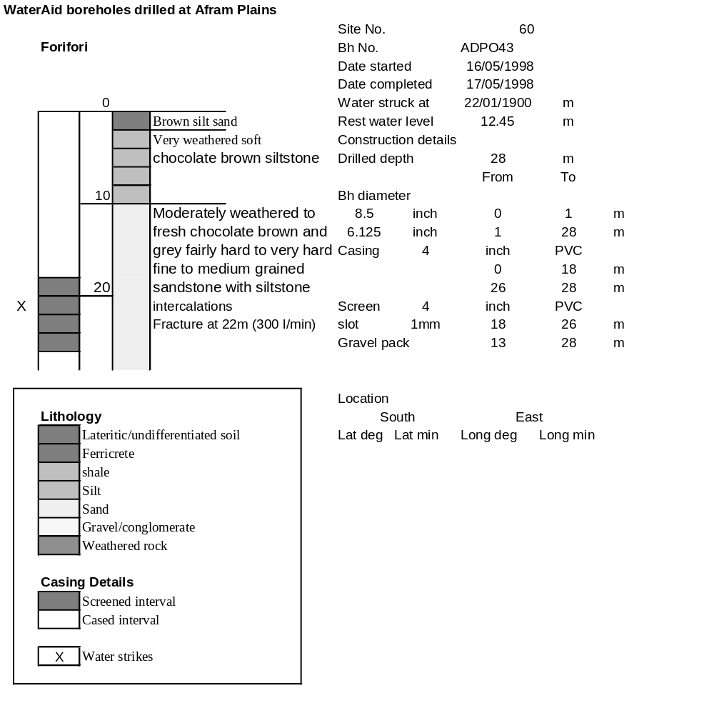

Ghana | Test pumping
Borehole No. |  | APDO43
Hole No |  | 60 | (10)
Village |  | Forifori
Date |  | 25/11/1998
Point above GL |  | 0.68 | m
Pump depth |  | 17 | m
SWL |  | 13.13 | m
Start Time |  | 07:30
Drawdown test |  |  |  |  | Recovery Test
time | pwl (m) | Q l/min | dd | sc(q/s) | Time | wl (m) | t/t' | resdd
0.00 | 13.13 | 250.00 | 0.00 |  | 0.00 | 14.94 |  | 1.81
1.00 | 13.82 | 250.00 | 0.69 | 362.32 | 1.00 | 13.91 | 241.00 | 0.78
2.00 | 13.93 | 250.00 | 0.80 | 312.50 | 2.00 | 13.86 | 121.00 | 0.73
3.00 | 14.07 | 250.00 | 0.94 | 265.96 | 3.00 | 13.82 | 81.00 | 0.69
4.00 | 14.12 | 250.00 | 0.99 | 252.53 | 4.00 | 13.80 | 61.00 | 0.67
5.00 | 14.25 | 250.00 | 1.12 | 223.21 | 5.00 | 13.79 | 49.00 | 0.66
6.00 | 14.28 | 250.00 | 1.15 | 217.39 | 6.00 | 13.78 | 41.00 | 0.65
7.00 | 14.30 | 250.00 | 1.17 | 213.68 | 7.00 | 13.77 | 35.29 | 0.64
8.00 | 14.31 | 250.00 | 1.18 | 211.86 | 8.00 | 13.77 | 31.00 | 0.64
9.00 | 14.32 | 250.00 | 1.19 | 210.08 | 9.00 | 13.76 | 27.67 | 0.63
10.00 | 14.33 | 250.00 | 1.20 | 208.33 | 10.00 | 13.76 | 25.00 | 0.63
12.00 | 14.35 | 250.00 | 1.22 | 204.92 | 12.00 | 13.75 | 21.00 | 0.62
14.00 | 14.37 | 250.00 | 1.24 | 201.61 | 14.00 | 13.74 | 18.14 | 0.61
16.00 | 14.38 | 250.00 | 1.25 | 200.00 | 16.00 | 13.73 | 16.00 | 0.60
18.00 | 14.39 | 250.00 | 1.26 | 198.41 | 18.00 | 13.73 | 14.33 | 0.60
20.00 | 14.40 | 250.00 | 1.27 | 196.85 | 20.00 | 13.72 | 13.00 | 0.59
25.00 | 14.42 | 250.00 | 1.29 | 193.80 | 25.00 | 13.71 | 10.60 | 0.58
30.00 | 14.44 | 250.00 | 1.31 | 190.84 | 30.00 | 13.70 | 9.00 | 0.57
35.00 | 14.45 | 250.00 | 1.32 | 189.39 | 35.00 | 13.69 | 7.86 | 0.56
40.00 | 14.47 | 250.00 | 1.34 | 186.57 | 40.00 | 13.68 | 7.00 | 0.55
45.00 | 14.49 | 250.00 | 1.36 | 183.82 | 45.00 | 13.67 | 6.33 | 0.54
50.00 | 14.50 | 250.00 | 1.37 | 182.48 | 50.00 | 13.67 | 5.80 | 0.54
55.00 | 14.51 | 250.00 | 1.38 | 181.16 | 55.00 | 13.67 | 5.36 | 0.54
60.00 | 14.53 | 250.00 | 1.40 | 178.57 | 60.00 | 13.66 | 5.00 | 0.53
70.00 | 14.56 | 250.00 | 1.43 | 174.83 | 70.00 | 13.65 | 4.43 | 0.52
80.00 | 14.60 | 250.00 | 1.47 | 170.07 | 80.00 | 13.65 | 4.00 | 0.52
90.00 | 14.62 | 250.00 | 1.49 | 167.79 | 90.00 | 13.64 | 3.67 | 0.51
100.00 | 14.64 | 250.00 | 1.51 | 165.56 | 100.00 | 13.63 | 3.40 | 0.50
110.00 | 14.66 | 250.00 | 1.53 | 163.40 | 110.00 | 13.63 | 3.18 | 0.50
120.00 | 14.69 | 250.00 | 1.56 | 160.26 | 120.00 | 13.62 | 3.00 | 0.49
130.00 | 14.71 | 250.00 | 1.58 | 158.23
140.00 | 14.74 | 250.00 | 1.61 | 155.28
150.00 | 14.76 | 250.00 | 1.63 | 153.37
160.00 | 14.78 | 250.00 | 1.65 | 151.52
170.00 | 14.80 | 250.00 | 1.67 | 149.70
180.00 | 14.81 | 250.00 | 1.68 | 148.81
190.00 | 14.83 | 250.00 | 1.70 | 147.06
200.00 | 14.85 | 250.00 | 1.72 | 145.35
210.00 | 14.87 | 250.00 | 1.74 | 143.68
220.00 | 14.90 | 250.00 | 1.77 | 141.24
230.00 | 14.91 | 250.00 | 1.78 | 140.45
240.00 | 14.94 | 250.00 | 1.81 | 138.12

